Kellie Turchetta

Southern New Hampshire University

CS-340

Milestone One

1. . Develop a function to create a document in the MongoDB database “city” in the collection “inspections.” Be sure it can handle error conditions gracefully.

a. Input -> argument to function will be set of key/value pairs in the data type acceptable to the MongoDB driver insert API call

b. return -> True if successful insert else False (require a screenshot)



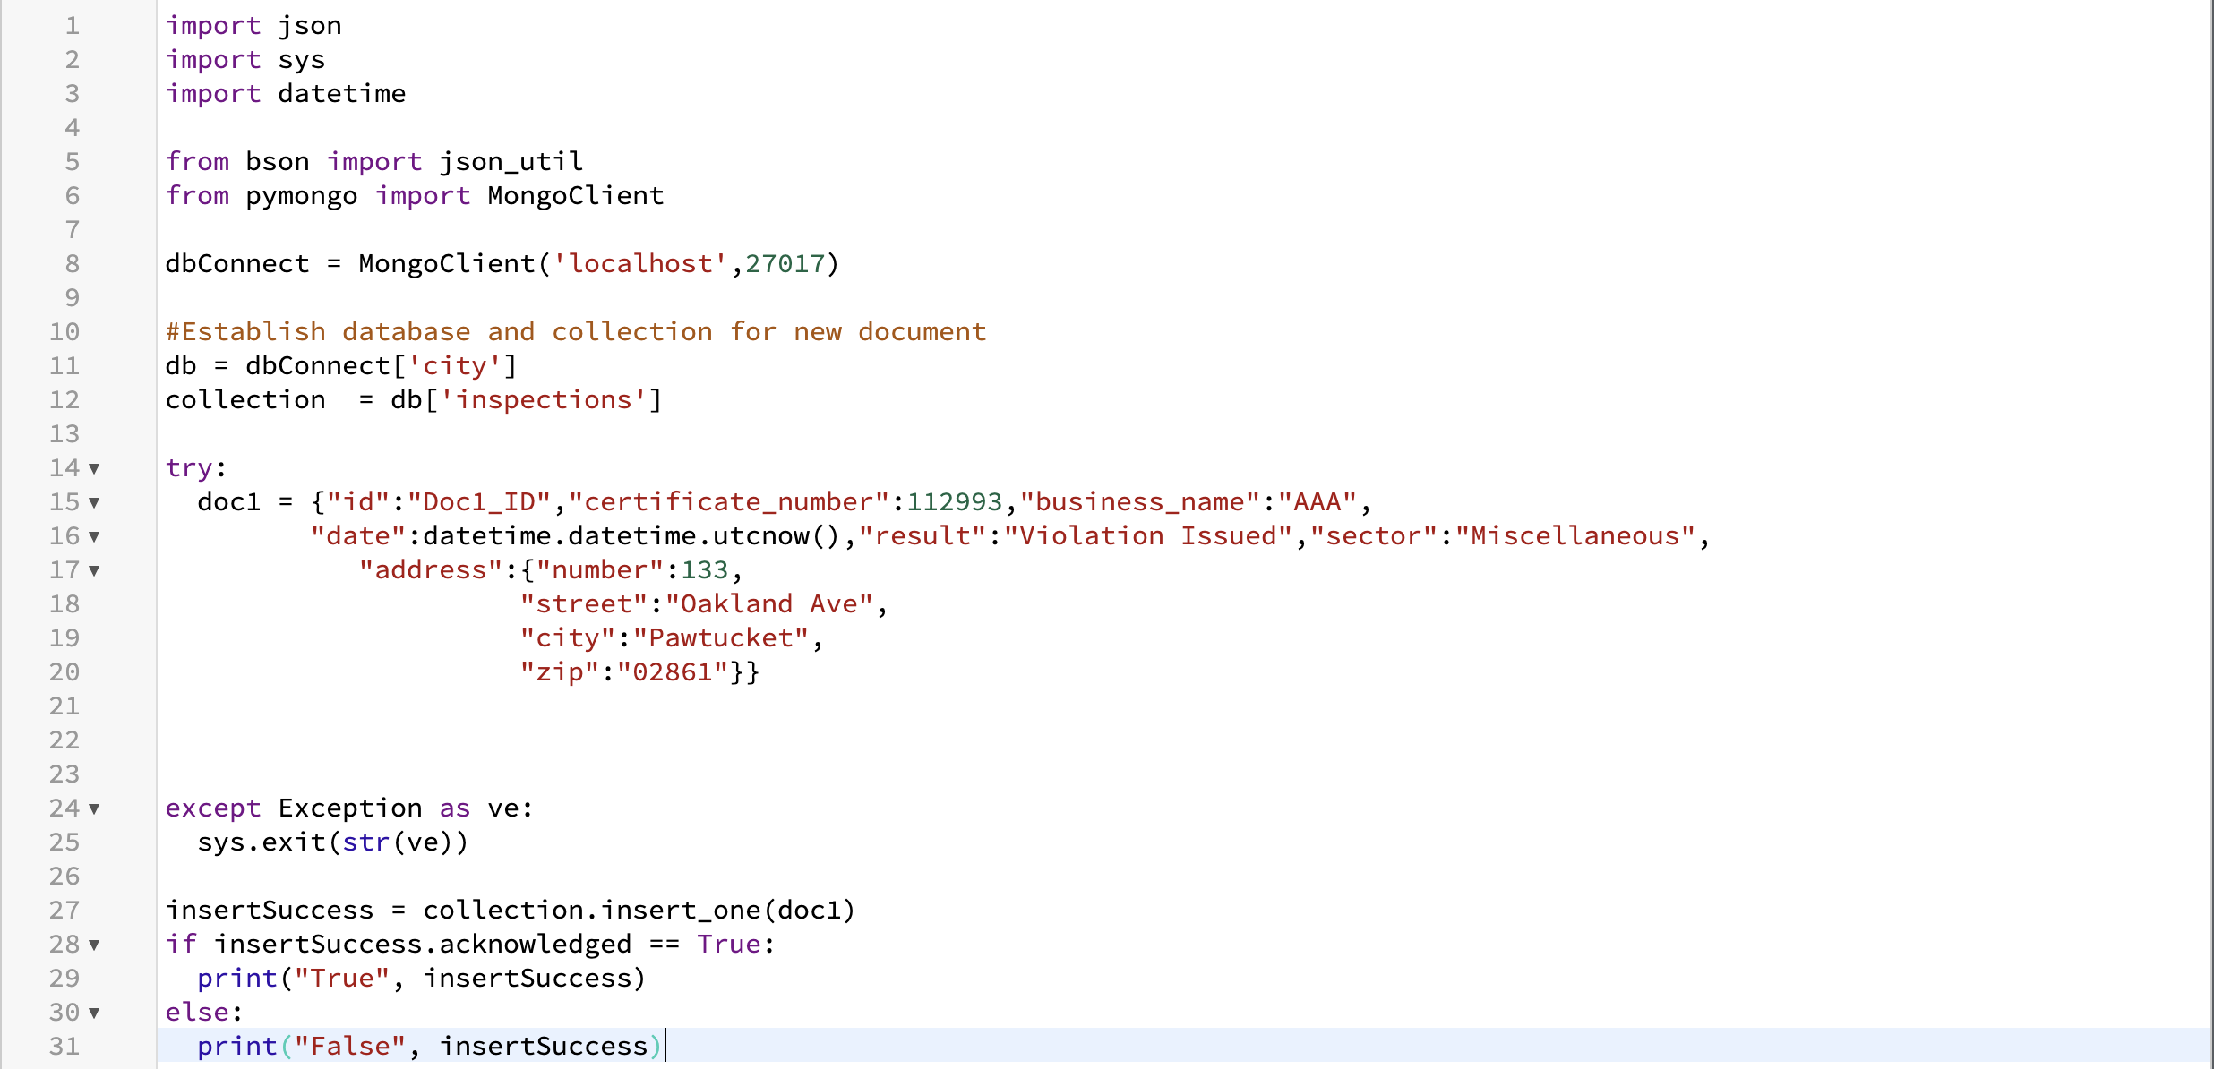

2. Develop a function to read a document in the MongoDB database “city” in the collection “inspections.” Be sure it can handle error conditions gracefully.

a. Input -> arguments to function should be the key/value lookup pair to use with the MongoDB driver find API call

b. return -> result in JSON format if successful else MongoDB returned error message

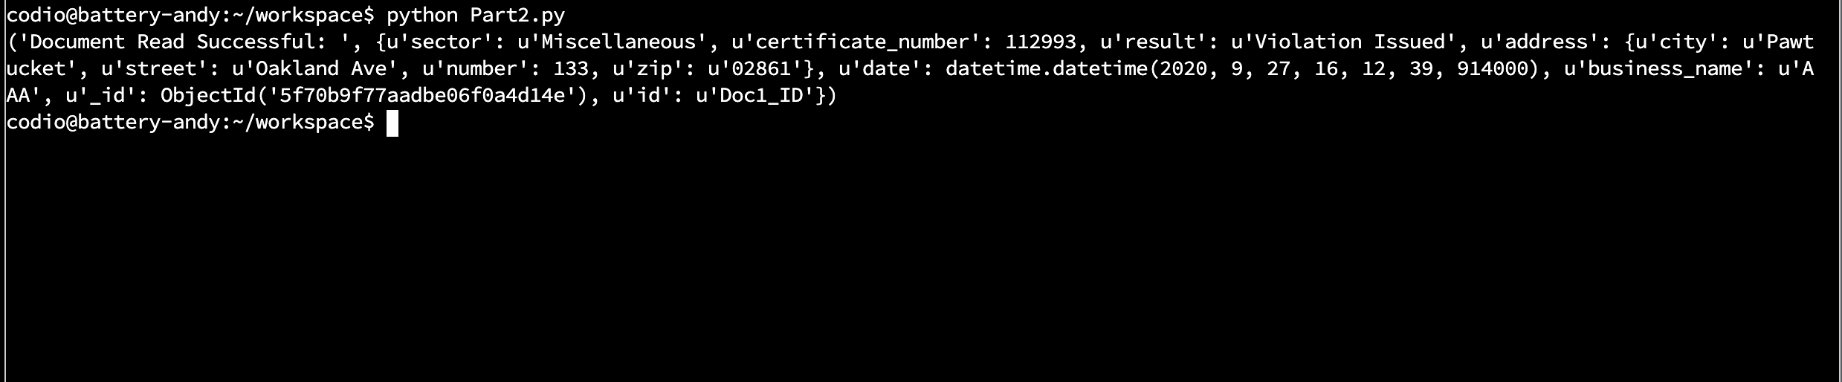

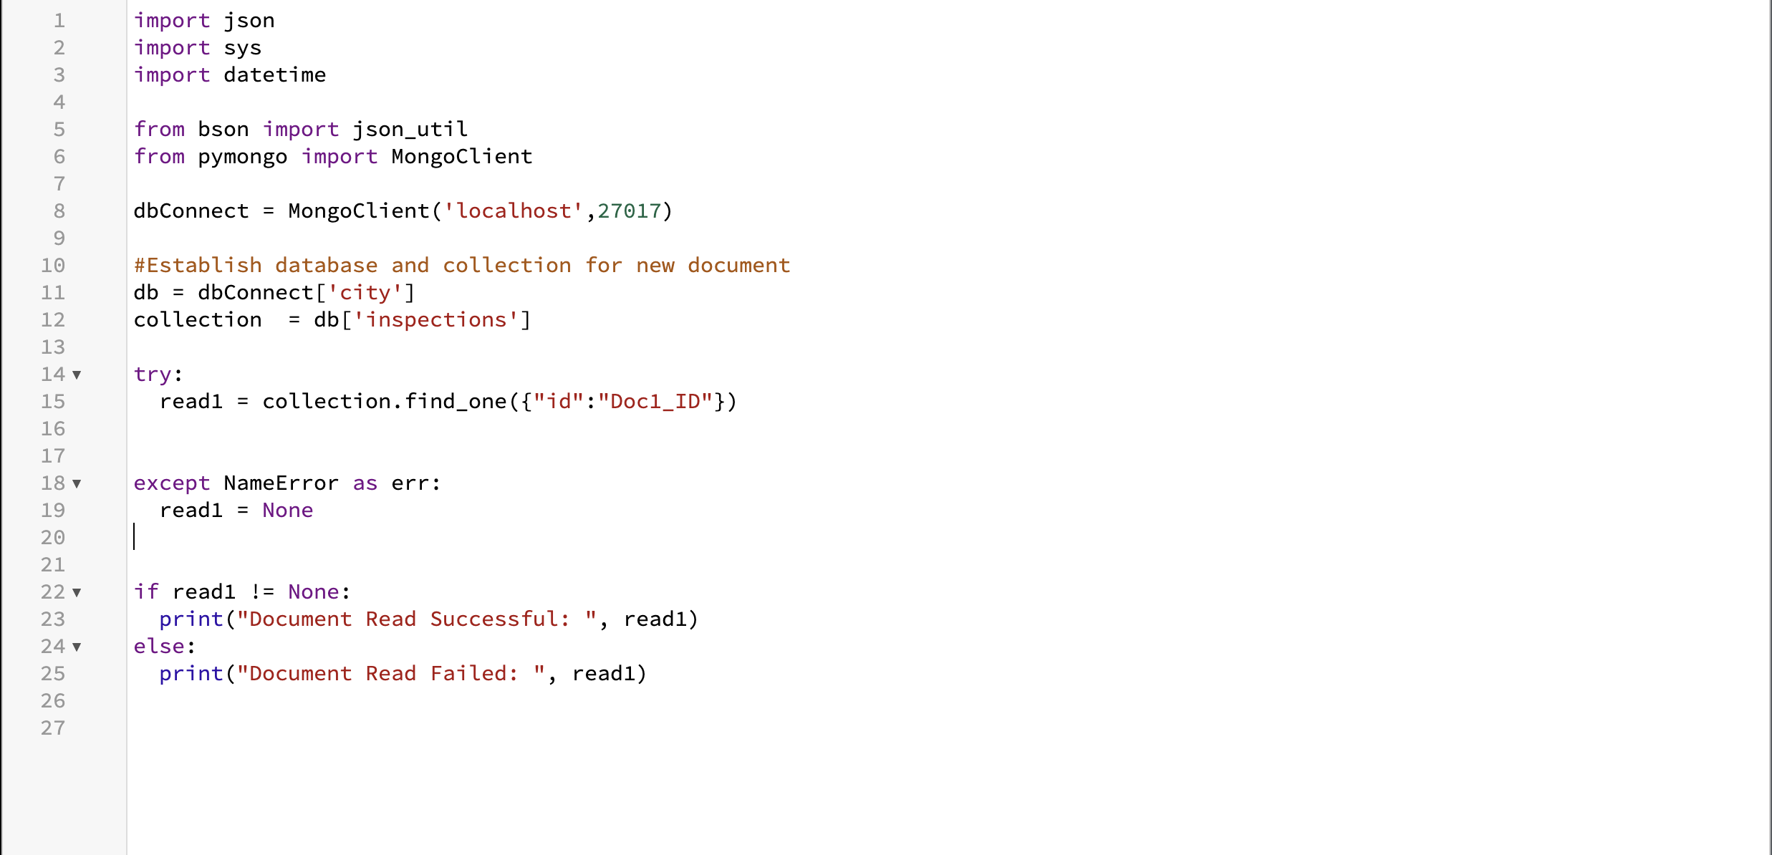

3. Develop a function to update a document in the MongoDB database “city” in the collection “inspections.” Be sure it can handle error conditions gracefully.

a. Input -> arguments to function should be the key/value lookup pair to use with the MongoDB driver find API call. Last argument to function will be set of key/value pairs in the data type acceptable to the MongoDB driver insert API call.

b. return -> result in JSON format if successful else MongoDB returned error message



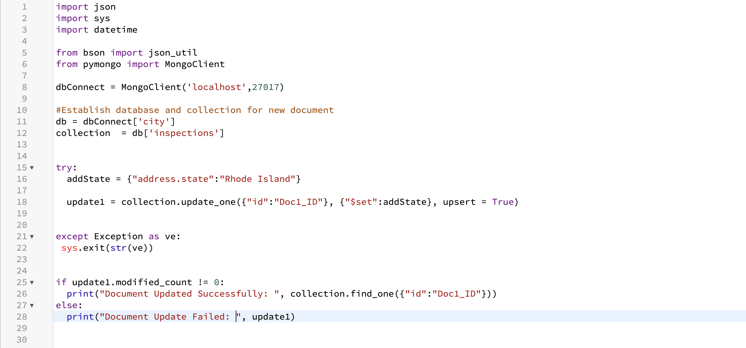

4. Develop a function to delete a document in the MongoDB database “city” in the collection “inspections.” Be sure it can handle error conditions gracefully.

a. Input -> arguments to function should be the key/value lookup pair to use with the MongoDB driver find API call

b. return -> result in JSON format if successful else MongoDB returned error message



